Couplings

Bibby Couplings
Vernier Couplings
Universal Couplings
Crown tooth gear
Fenner tooth belt drive
Helical drive

INTRODUCTION

A mechanical connection is used to connect a driver to a driven. This is common terminology and is in fact a coupling, which is, used to connect, say, a motor to a gearbox. On today’s modern electric winders we may find several different types of couplings.
A good practical knowledge of these different types of connections and the maintenance of them is essential.

In this module we will deal with the following types of connections:

Vernier couplings
Universal couplings
Crown tooth gear
Fenner tooth belt drive
Helical gear drive

VERNIER COUPLINGS

If you are familiar with a Vernier caliper, then the first thought to enter your mind when you hear the word Vernier coupling is that they both have something in common, that is they both give you fine settings.
The coupling, as its name states, is a way of connecting a driver and driven. Fig. F.C.9 – 15(1).1.4 illustrate a Vernier coupling.

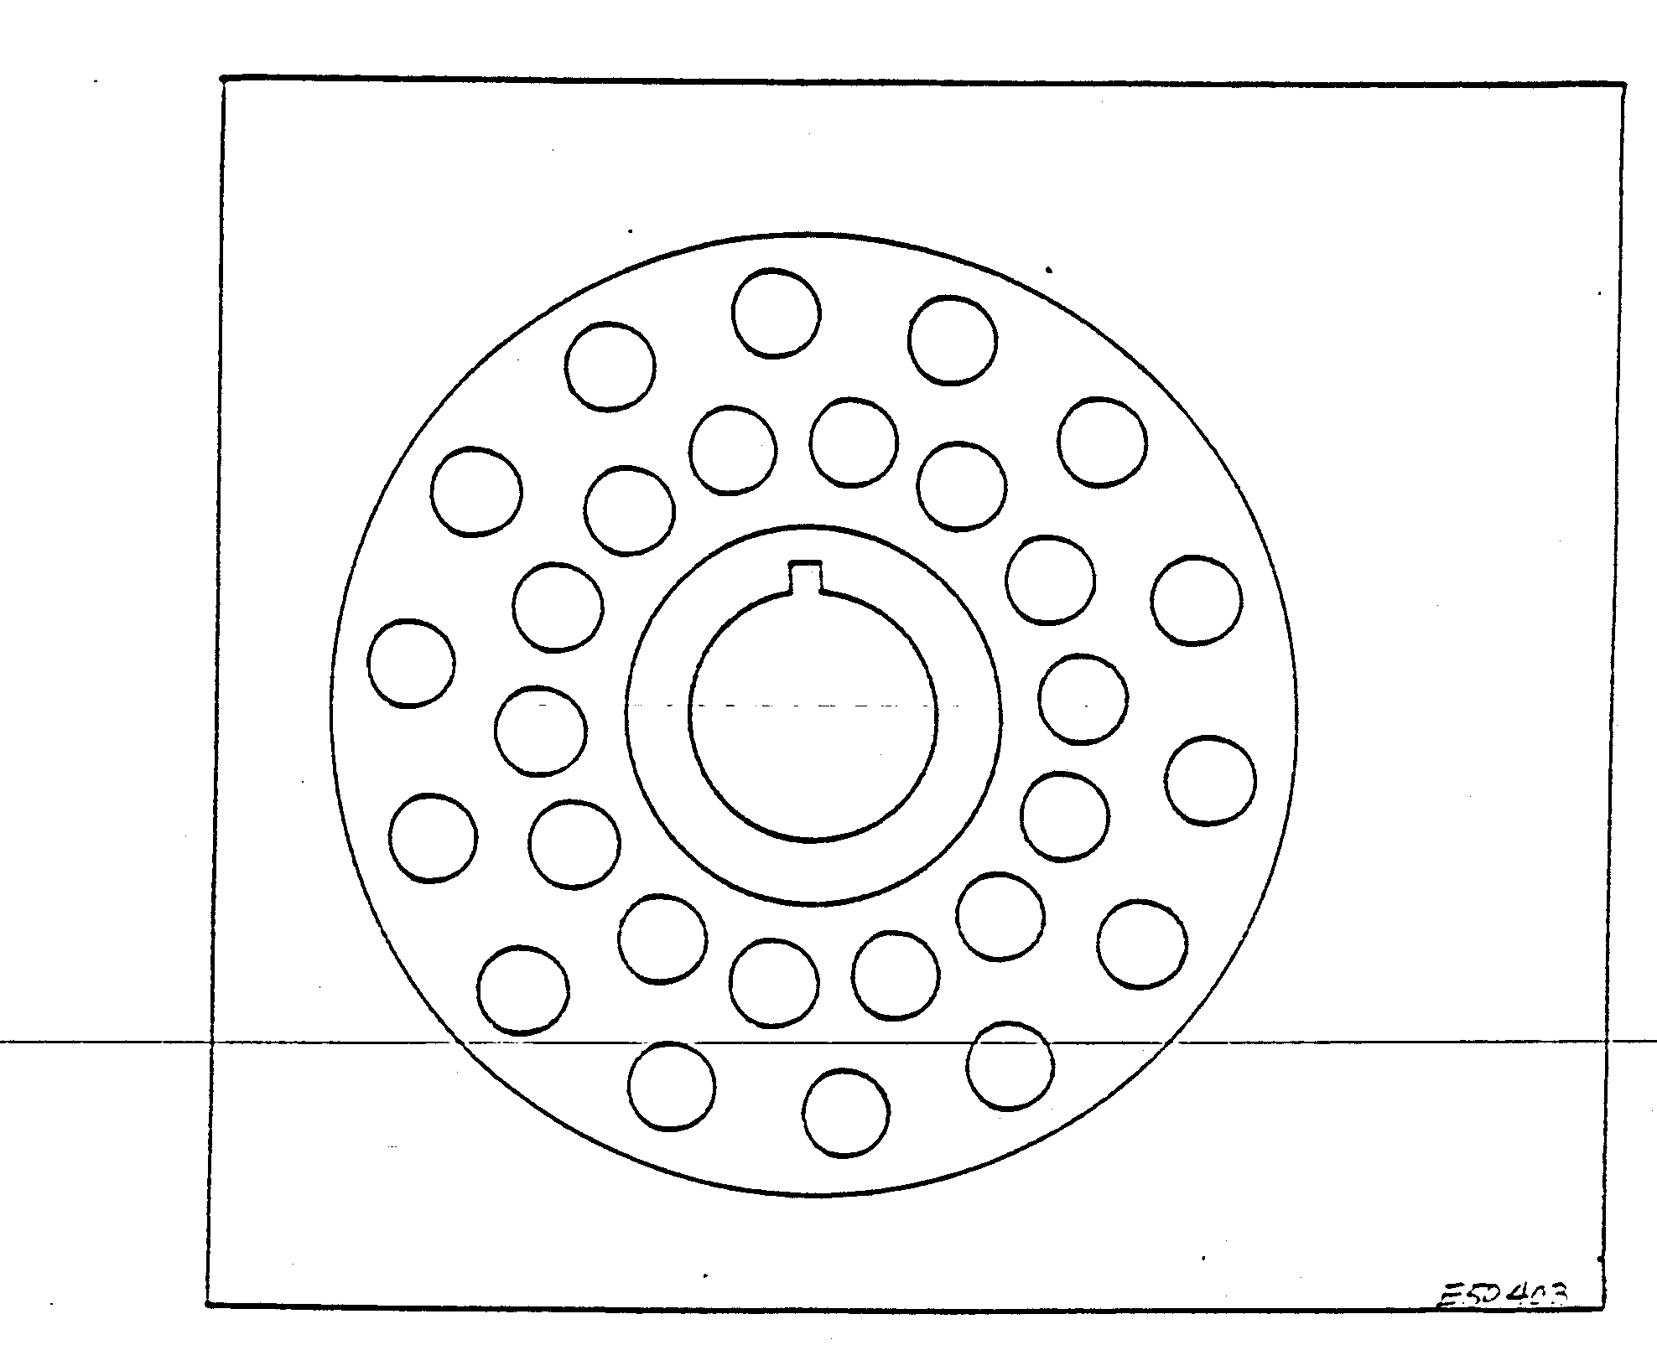
As you can see in Fig. F.C.9 – 15(1).1.4, the coupling has holes reamed to size, which are drilled in two rows around its face. This enables you to turn the coupling half in either direction and set to a specific position. There will always be two holes corresponding, one on the inner P.C.D. (pitch circle diameter) and the other on the outer P.C.D.
The couplings are bolted together with two bolts only. These bolts are machined and fit neatly into the holes to prevent any movement.
The coupling should be checked for worn holes or keyways. If there is any wear, the coupling should be replaced. Never use a hammer on these couplings as they bend easily and, being machined mild steel, hammer marks will show.
UNIVERSAL COUPLINGS

The Universal coupling should be familiar to you as they are used extensively on motor cars.
On winders they are used on the speed controls and indicators and where it is impractical to use the conventional shafts and corner boxes, saving space. Also they are used to take short-cuts from the drums to the Lilly’s and indicators as shown in Fig. F.C.9 – 15(1).1.5.

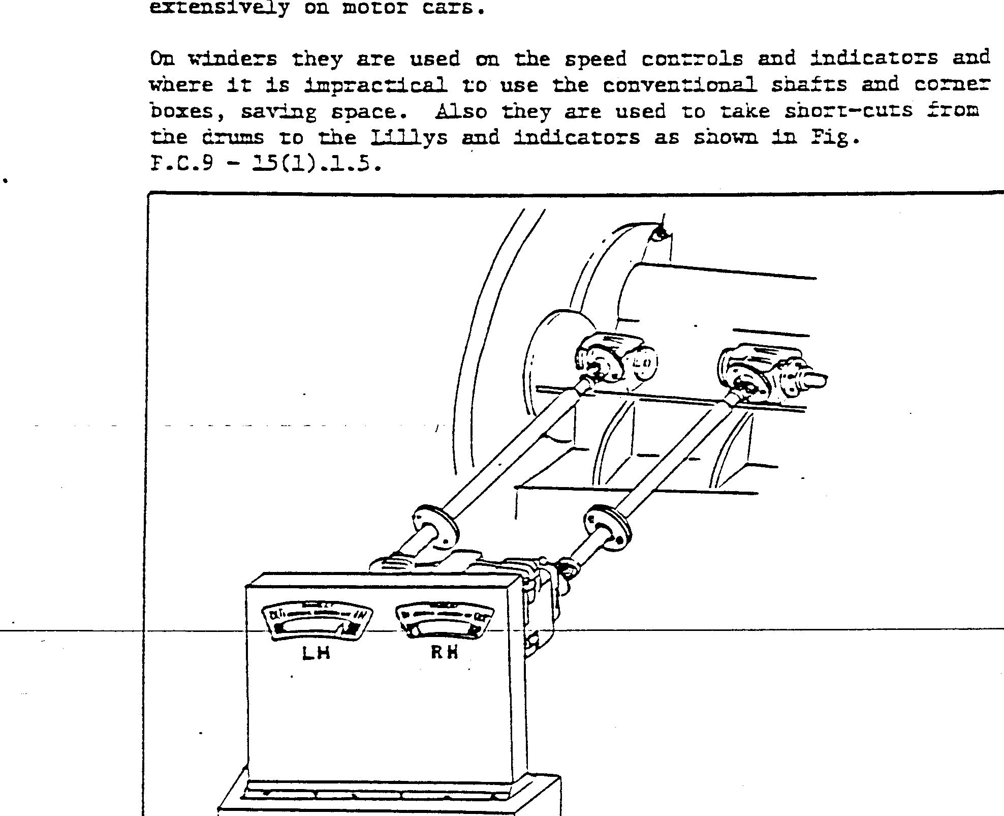
This type of coupling needs very little attention, only weekly examinations. If these couplings are lubricated regularly you will have few problems, for it is only when they run dry that the needle rollers become damaged, causing backlash to develop. In this case a new universal will have to be fitted. Fig. F.C.9 – 15(1).1.6 illustrate a typical universal and its components.

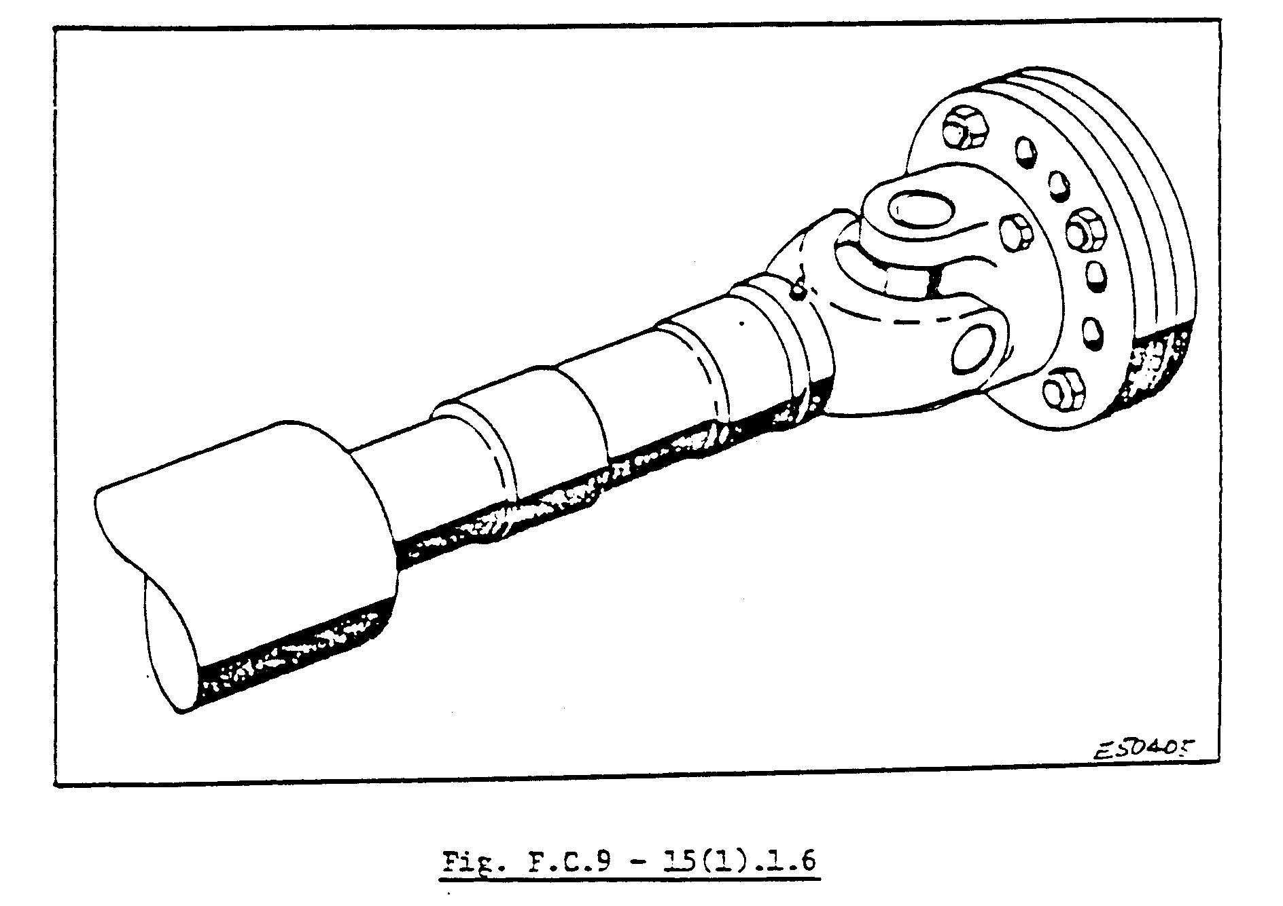
CROWN TOOTH GEAR

The crown gear looks like a crown, as its name implies. It has many uses on the winder, for example on the corner boxes where you will see the drive shaft driving the Lilly coming out at a 90 ° angle. Fig. F.C.9 – 15(1).1.7 illustrate a crown tooth gear in a corner box.

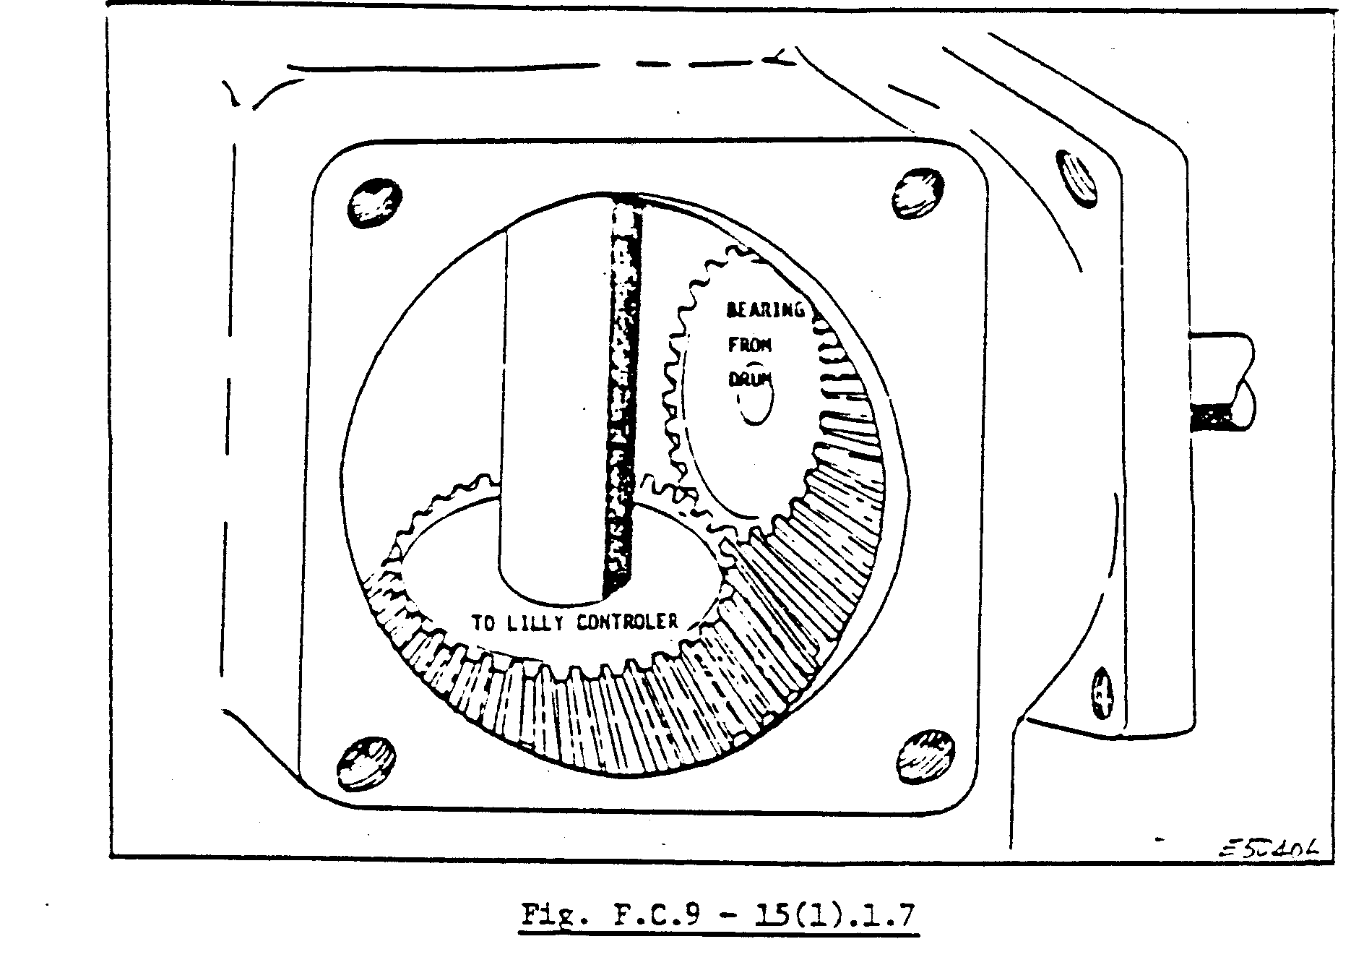
The corner box drive must be checked regularly for backlash, worn or broken bearings, which could cause worn teeth and too much play on the gears. This will result in the malfunctioning of the Lilly and indicators.
If the gears are excessively worn, resulting in too many backlashes, they should be changed. Backlash can be removed by moving the gears closer to one another, making the teeth mesh deeper.
You must take care that the teeth do not mesh too deeply as this will result in excessive wear and overheating. We will discuss this drive in more detail when we do the indicators and their components.

FENNER TOOTH BELT DRIVE

The Fenner tooth belt is used on the winder to drive the tachogenerator and the speed indicators, driven from the main shaft by a series of pulleys. The reason for using pulleys of different size is to obtain the correct revolutions specified for that particular winder.
Fig. F.C.9 – 15(1).1.8 illustrate a typical Fenner tooth belt.

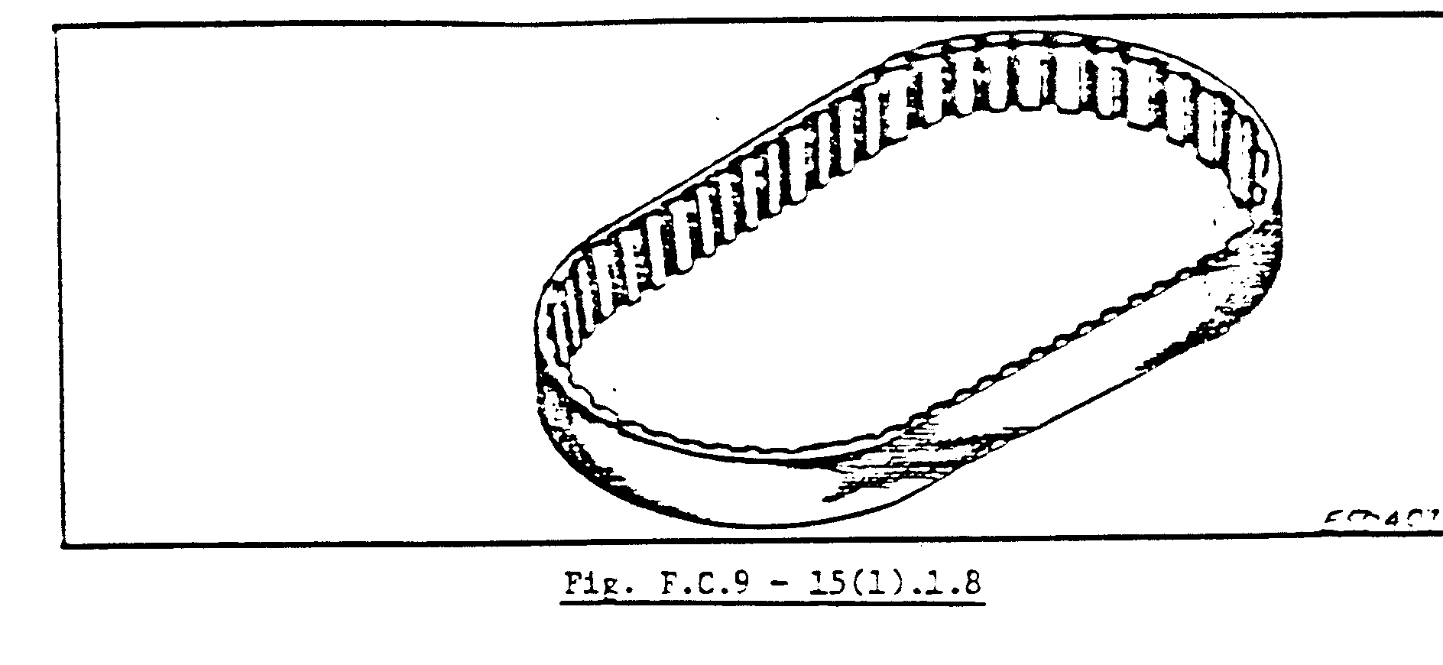
As you can see in Fig. F.C.9 – 15(1).1.8, the belt have little strips across its face. These act as teeth to prevent any slipping. The pulleys also have the same grooves or teeth in them to correspond with the belt as shown in Fig. F.C.9 – 15(1).1.9.

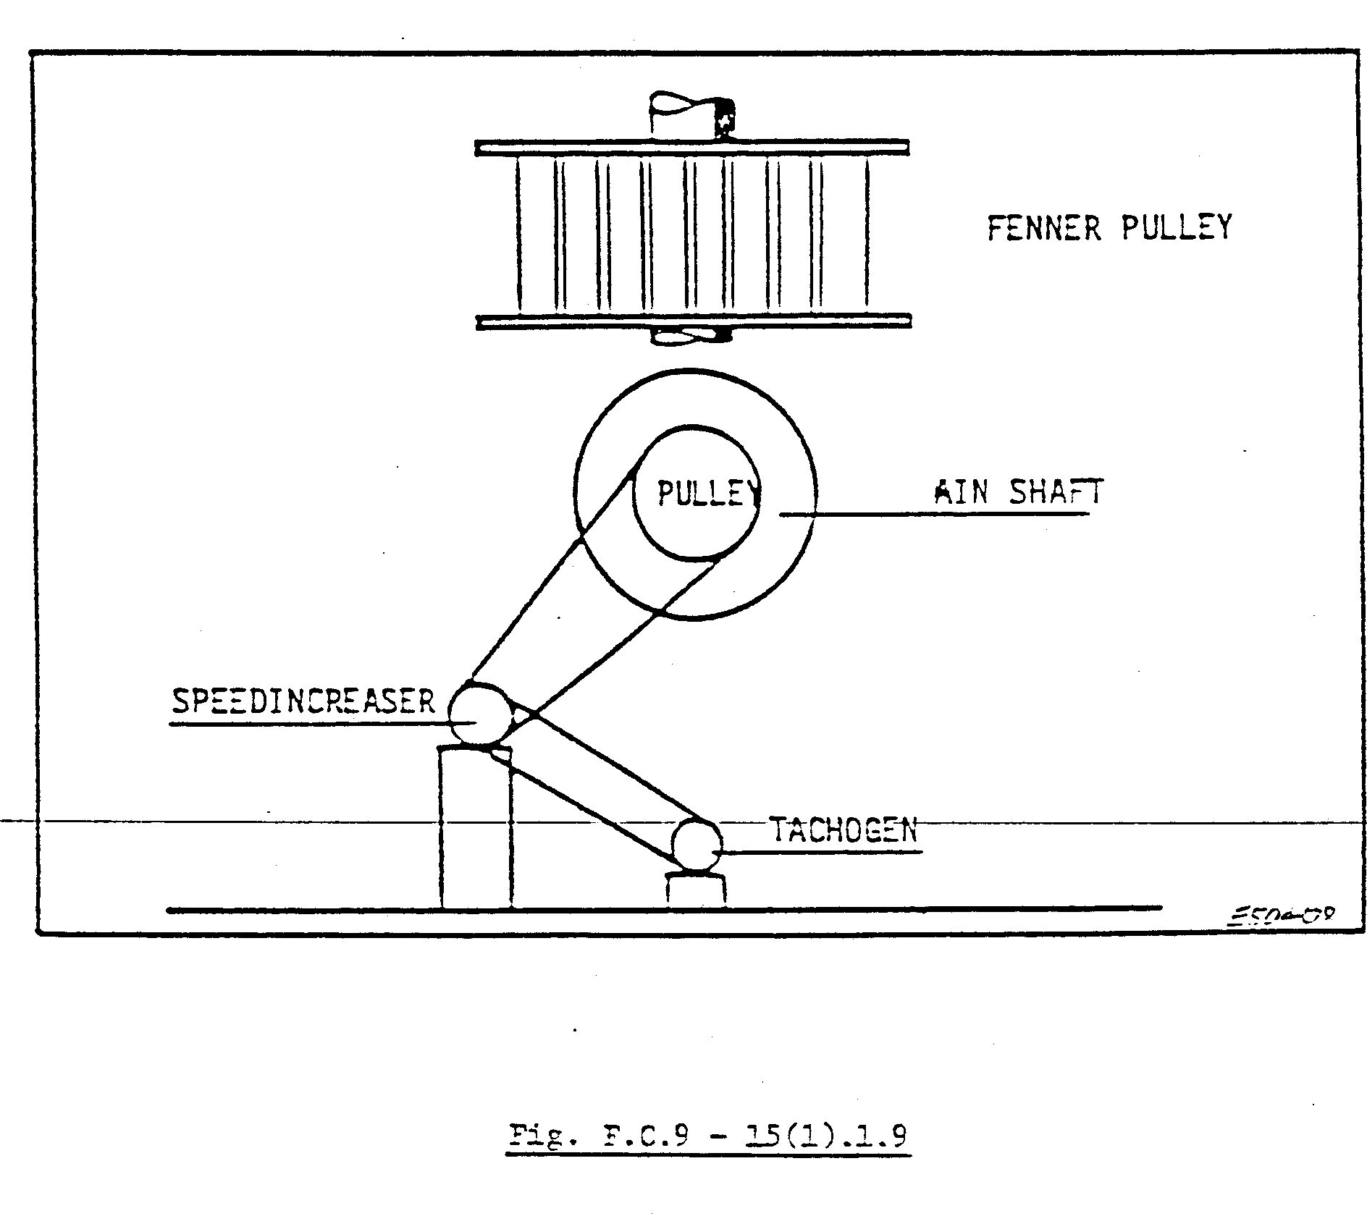
Fig. F.C.9 – 15(1).1.9 also show how the Fennet tooth belt is used to drive the tachogenerator and speed indicator.
. Maintaining the Fenner tooth belt drive on the winder needs regular attention. You must check weekly during hoist examination for alignment and wear on the belts. You will easily detect if the drive is not right by checking your tachograph. You will note that the graph drawn is irregular, as shown in Fig. F.C.9 – 15(1).1.10. If this occurs, the “teeth” of the belts are worn or damaged or a piece of waste has come between the belts and pulley. If the belt is damaged it must be changed.

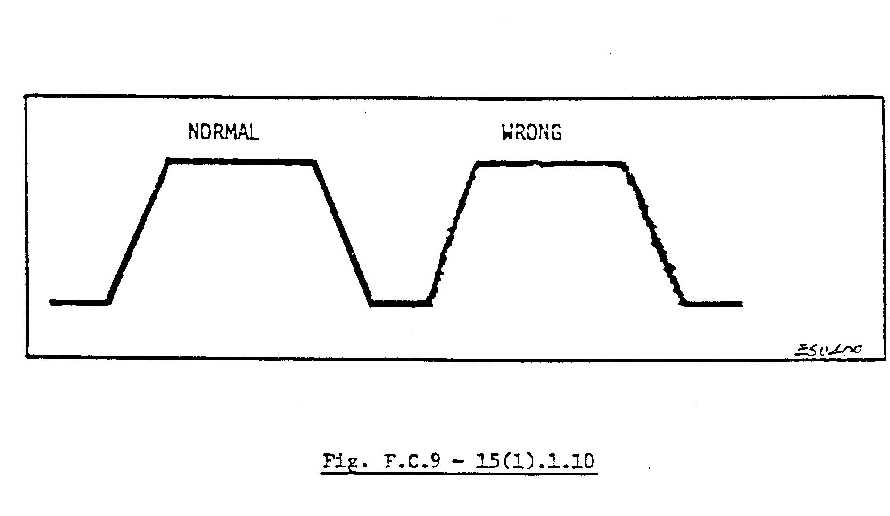
When fitting a new belt, care must be taken not to have too much or too little tension. You must be able to depress the belt with your thumb for + 25 – 30 mm, depending on the length of the belt. Check the teeth of the pulleys for any pieces of waste or grease. Proper guards must be fitted as required by The Mines and Works Act and Regulation No. 20.5, which states:
“All exposed machinery which, when in motion, may be dangerous to any person shall be securely fenced off. Efficient guards shall be provided to such parts of any machinery as may be a source of danger to any person”.

HELICAL GEAR DRIVE

Fig. F.C.9 – 15(1).1.11 are an illustration of a helical gear arrangement for a single-motor drive.
Accurately-cut double-helical gears have played an important part in the development of the winder.
For geared winders it is not necessary to have unduly high ratios or excessive pitch line speeds, hence the gear ratio for a winder seldom exceeds 10 to 1, and ratios of 7 ½ to 1 to 15 to 1 is the norm for speeds up to 15 m per second.
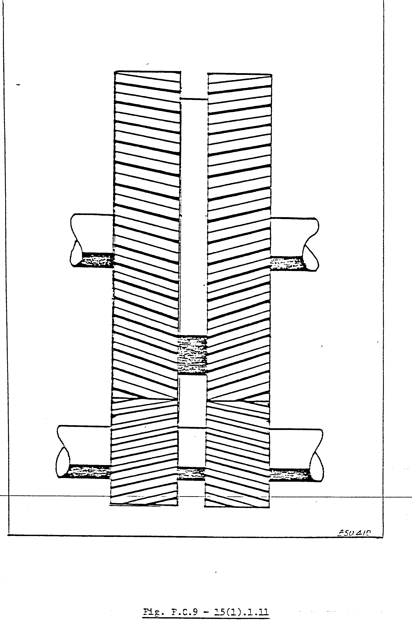
Of the gear arrangement shown in Fig. F.C.9 – 15(1).1.12, the simple layout (A) is generally favored and has been used for single-motor winder drives up to 3 000 h.p. at 360 r.p.m.

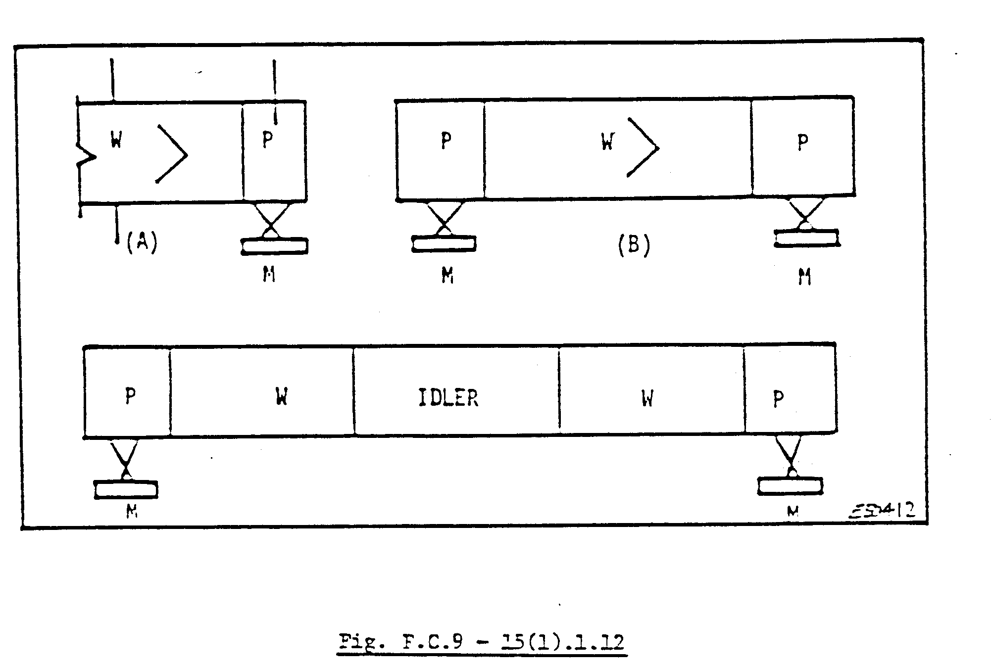
The twin-motor drive (B) is frequently used for large winders with ratings of 2 x 2 100 h.p. (1 641 kW) and a speed of 61 – 287 r/min.
Arrangement C, of which there are numerous examples, is a twin-motor tandem drive. The winder drums are mounted behind one another. The idler gear, which is interposed between the two gear wheels, synchronizes the motion of the two drums.
Irrespective of arrangement, it is desirable that the wheel and pinion bearings should be mounted on a common bed plate, and the wheels must be secured by tangential keys, i.e. keys which are fitted tight on the side of the keyway and not top and bottom as with normal keys.
The bearings should be of the spherical-sealed, self-aligning, ring-oiling, two part type, divided across a horizontal diameter.
The pinions are made of high-carbon steel forgings and the gear wheels of steel castings.
The gearbox encloses the whole range of gears and is lubricated for force lubrication from a gear pump through sprays led from a tank holding 410 litters’ oil. A standby pumps and flows meter is provided in case a pump breaks down on there is a power failure, then the safety circuit will trip out.
Monthly inspections are done by the Fitter and/or Foreman and Engineer, for wear on the teeth and on the keys of the shaft.
A yearly examination by the N.D.T. Department must be done to check for cracks on the gear wheels, pinions and spokes.
Maintenance must be done as per your mine’s maintenance schedule.

